 | GRADES 4-8 ~ Text Dependent Analysis Rubric | Not Yet | Starting To | Yes
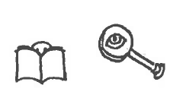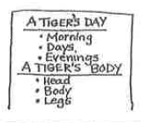 | I effectively addressed all parts of the task demonstrating in-depth understanding of the text(s).  - Read question/task, read closely, stop and jot, (annotate) take notes, reread notes | □ | □ | □
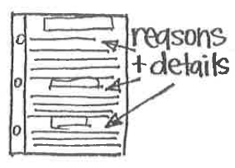 | I have a strong organizational structure that effectively supports the focus and ideas.  - Use Boxes & Bullets (claim, reasons, examples) | □ | □ | □
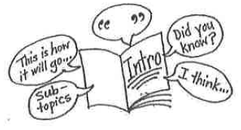 | I effectively introduced, developed, and concluded by identifying an opinion, topic, or controlling idea related to the text(s).  - Restate the task by using ways readers state theme or ideas of the text | □ | □ | □
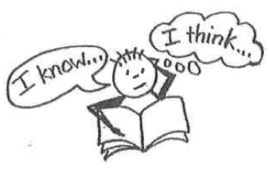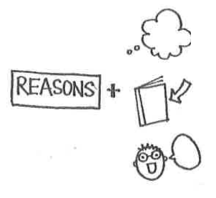 | I included thorough analysis of explicit and implicit meanings from text(s) to effectively support claims, opinions, ideas and inferences.  - What did I find? Where did I find it? What does it make me think? | □ | □ | □
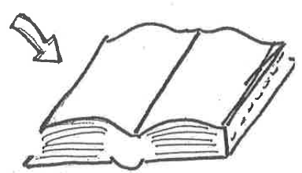 | I included substantial, accurate, and direct reference to the text(s) using relevant key details, examples, quotes, facts, and/or definitions.  - Use quotations from the text | □ | □ | □
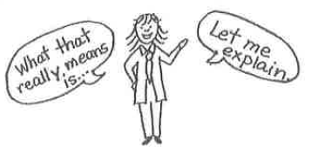 | I included substantial reference to the main idea(s) and relevant key details of the text(s) to support the writer’s purpose. | □ | □ | □
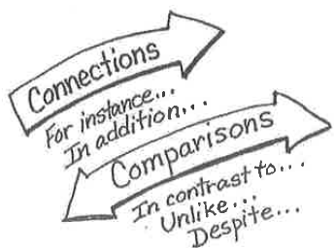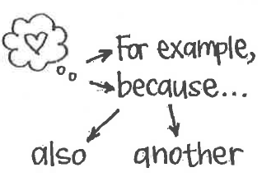 | I skillfully used transitions to link ideas; appropriate and varied transitions to create cohesion and clarify the relationships among ideas and concepts. | □ | □ | □
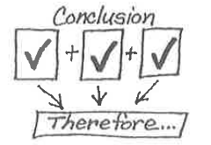 | I provided a concluding section that follows from and supports the analysis presented. | □ | □ | □
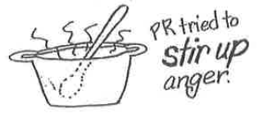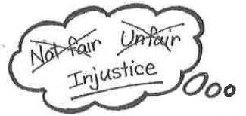 | Effective use of precise language and domain-specific vocabulary drawn from the text(s) to explain the topic and/or to convey experiences/events. | □ | □ | □
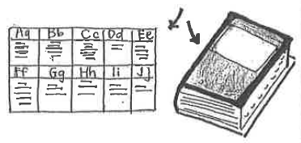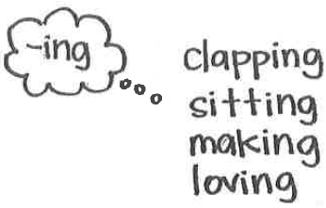 | I reread the piece to make sure words I know are spelled accurately, and to ensure spelling does not take away from the meaning; errors present do not interfere with meaning. | □ | □ | □
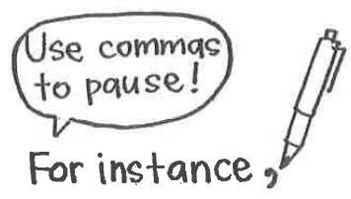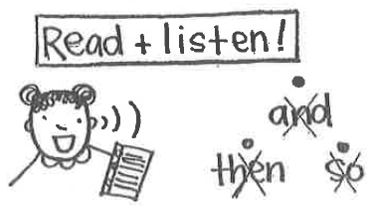 | I reread the piece to make sure few errors, if any, are present in sentence formation, grammar, usage, capitalization, and punctuation; errors present do not interfere with meaning. | □ | □ | □
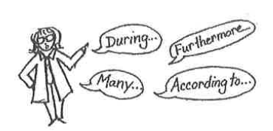  Adapted from: Calkins, L. (2014). Writing pathways: Performance assessments and learning progressions, Grades K-8. Portsmouth, NH: Heinemann; and the Pennsylvania Department of Education Text Dependent Analysis Rubric (2014) | I established and maintained a formal style. | □ | □ | □
Adapted from: Calkins, L., & Hohne, K. (2015). Writing pathways: Performance assessments and learning progressions, Grades K-8. Portsmouth, NH: Heinemann; and the Pennsylvania Department of Education Text Dependent Analysis Rubric (2014)

