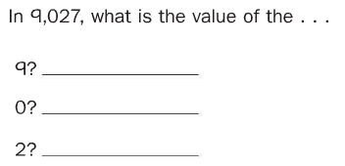

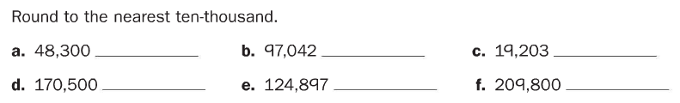

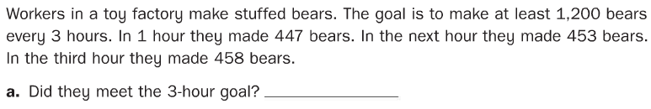
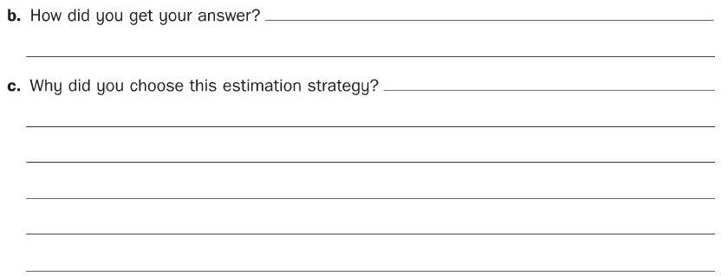

Make an estimate and then solve using U.S. traditional addition.
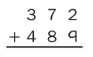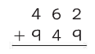

Make an estimate and then solve using U.S. traditional subtraction.

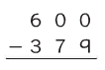

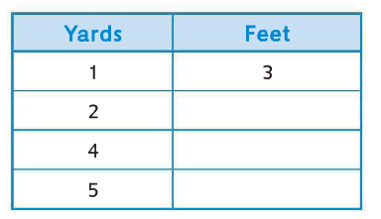
Explain how you figured out how many feet are in 5 yards.
_______________________________________________________________________________________________________________________________________________________________________________________________________________________________________

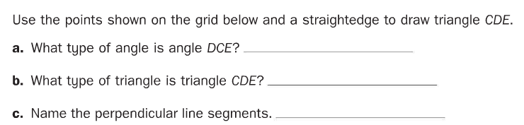
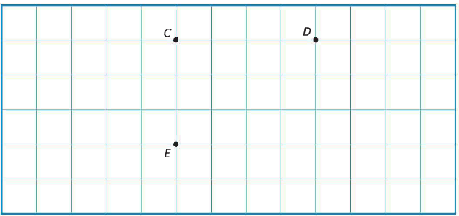

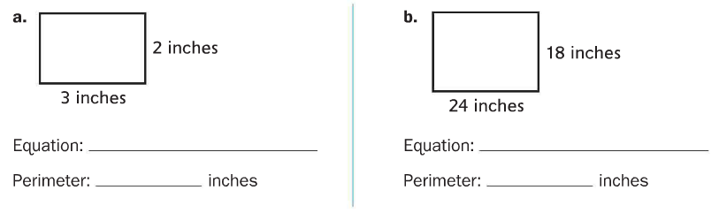
c. Explain how you found the perimeter for problem 9b.
_______________________________________________________________________________________________________________________________________________________________________________________________________________________________________

