

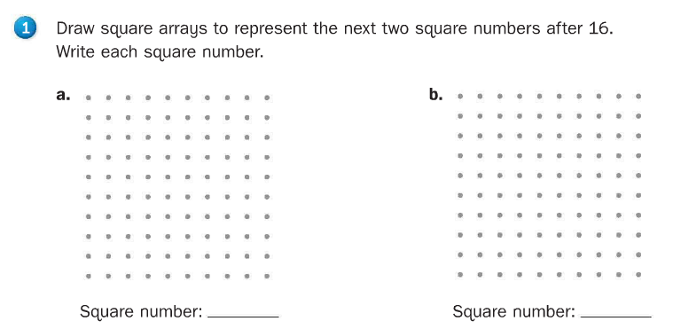

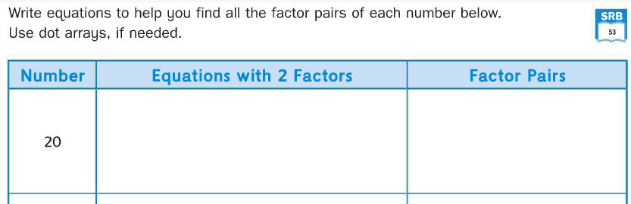

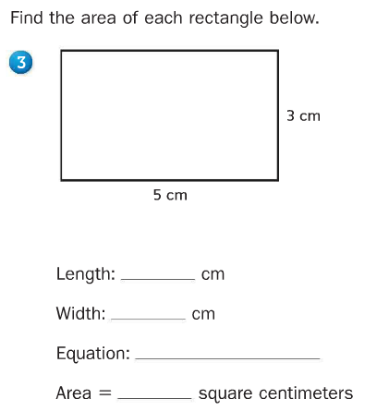

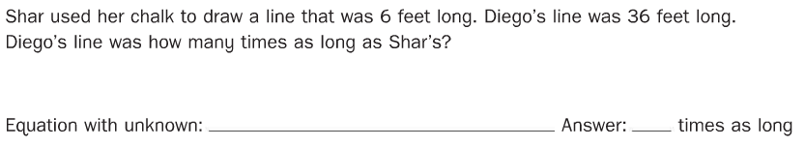



Name two properties of this quadrilateral.

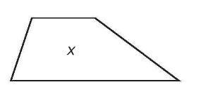

1. __________________________________________________________
2. __________________________________________________________

